Derivatives Non- Deliverable Forwards NDF-
CDO Participation within a project is based on the rating that the Data Risk Assessment came out.
For this specific project the DRA came out as High which results in CDO opting in the project. We should consider the gate 3 meeting date as when the DRA was reviewed and approved a decision from CDO cannot be performed unless the DRA is reviewed and approved by them.
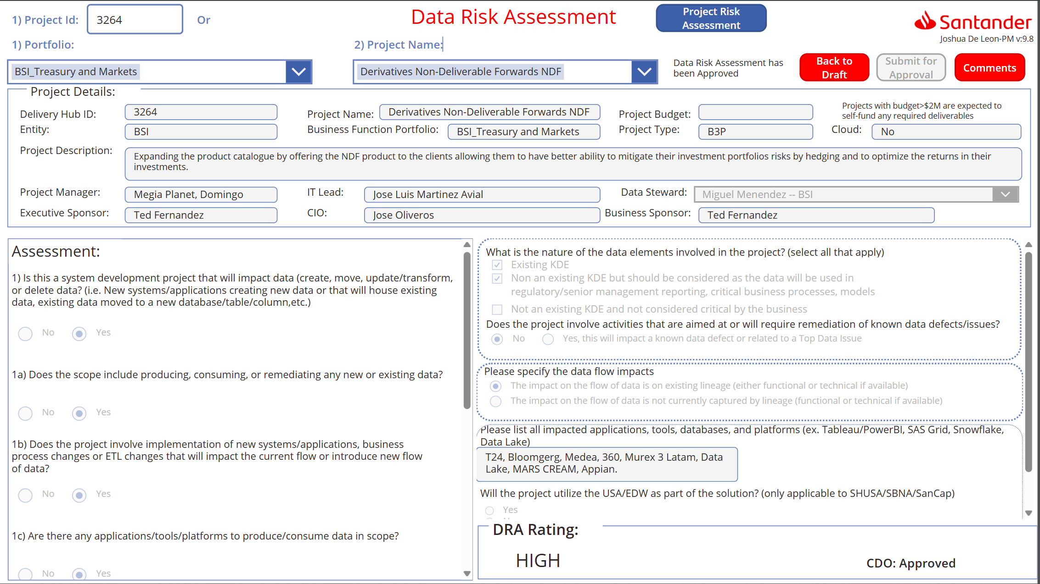
Gate disposition screen shot.
